**Course _____12 Methods_____ Year __12___**

Student name: ________________ Teacher name: ________________

**Task type: Response**

**Time allowed for this task: ____40_______ mins**

**Number of questions: _____7______**

**Materials required:** No calculators nor classpads

Standard items: Pens (blue/black preferred), pencils (including coloured), sharpener, correction fluid/tape, eraser, ruler, highlighters

Special items: Drawing instruments, templates, notes on one unfolded sheet of   
A4 paper, and up to three calculators approved for use in the WACE examinations

**Marks available: ___40___ marks**

**Task weighting: _10___%**

**Formula sheet provided: Yes**

**Note: All part questions worth more than 2 marks require working to obtain full marks.**

Q1 (2, 3 & 3 = 8 marks) (3.1.7-3.1.8)

Determine  for each of the following.(No need to simplify)

1. 
2. 
3. 

Q2 (2 & 3 = 5 marks) (3.1.8)

Consider  .

1. Determine 
2. Determine the equation of the tangent at 

Q3 (1, 1, 3 & 3 = 8 marks) (3.1.7-3.1.8, 3.1.15)

Consider the following functions .

|  |  |
| --- | --- |
|  |  |

1. Determine the derivative of  when 
2. Determine the derivative of  when 
3. Determine the derivative of  when .
4. Determine the derivative of  when .

Q4 (2, 3 & 2 = 7marks) (3.1.13 – 3.1.17)

The following is the graph of , the derivative of .

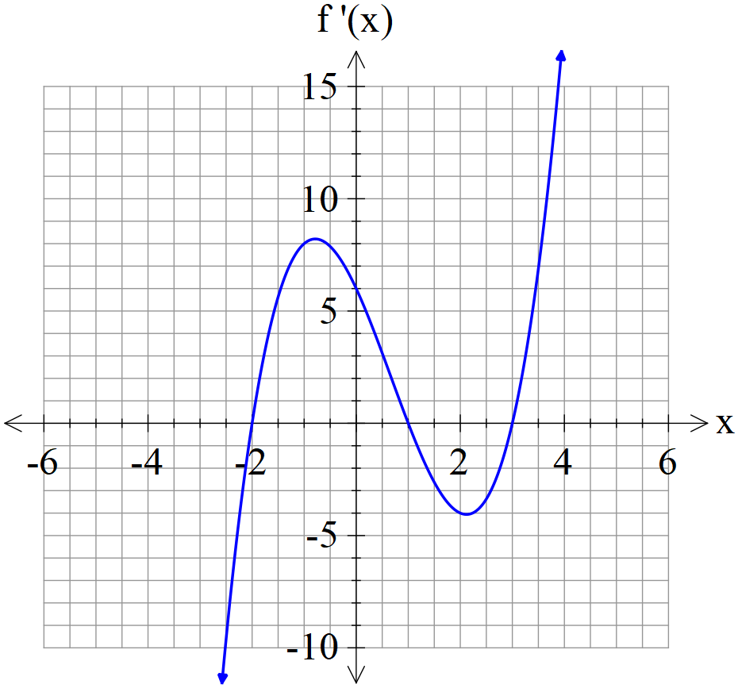

1. State the x values of all stationary points of .
2. State the nature of each stationary point above and justify.
3. State approximate x value for an infection point(s) and explain why.

Q5 (3 & 2 = 5 marks) (3.1.12)

The displacement of a body from the origin O, at time  seconds, is  metres where



1. Determine the time(s) that the velocity is zero metres/second.
2. Determine when the acceleration is zero.

Q6 (3 marks) (3.1.10)

The period  of a swinging pendulum of length  is given by .

Using the increments formula, determine the approximate percentage change in if  changes by 3%

.Q7 (4 marks) (3.1.16)

Consider a hollow cylindrical container that has one open end. The surface area of the container is . Determine the **exact** value of the radius of the closed end that maximises the volume. (Justify)

(Hint- refer to formula sheet)

